Sure-Park Management System

Software Architecture Design Document
Document ID : [5Team_Design_003]

5 (Oh!) Team
Copyright © 2016 5 (Oh!) Team All Rights Reserved.

Though every care has been taken to ensure the accuracy of this document, 5 (Oh!) Team cannot accept responsibility for any errors or omissions or for any loss occurred to any person, whether legal or natural, from acting, or refraining from action, as a result of the information contained herein. Information in this document is subject to change at any time without obligation to notify any person of such changes.

5 (Oh!) Team may have patents or patent pending applications, trademarks copyrights or other intellectual property rights covering subject matter in this document. The furnishing of this document does not give the recipient or reader any license to these patents, trademarks copyrights or other intellectual property rights.

No part of this document may be communicated, distributed, reproduced or transmitted in any form or by any means, electronic or mechanical or otherwise, for any purpose, without the prior written permission of 5 (Oh!) Team.

The document is subject to revision without further notice.

All brand names and product names mentioned in this document are trademarks or registered trademarks of their respective owners.

Document Information
5 (Oh!) Team,
LG Electronics,
Executive Training Program,
ISR(Institute for Software Research)
Carnegie Mellon.

Contact us: sanghee3.lee@lge.com

About This Document

Revision History
Version | Date | Comment | Author | Approval
0.1 | 2016-06-16 | Document outline, draft version | Sanghee Lee | Jaedo Jin

Purpose
This document describes architecture of SurePark Management System and the important decisions we have made.

Scope
This document includes overall and sub system architecture.

Audience
This document’s audience is as follows.
- All Stakeholders
- Project Manager
- Architect
- Development Team

Related Documents
Following documents can be reference for understand this document.
Document ID | Comment
5Team_Analysis_001 | Architectural Driver Specification (including contexts)
5Team_Design_001 | Interface description document
5Team_Design_004 | Database design document
5Team_Test_001 | Test strategy
5Team_Test_002 | Test cases
5Team_Test_003 | Test results
Glossary
Glossary in this document are described..
Glossary | Description
JSON | JavaScript Object Notation
CRC | Cyclic Redundancy Check
JDBC | Java Database Connectivity
SQL | Structured Query Language
WMS | Warehouse Management System
ITC | Inter Thread Communication

Contents
1.2.1 Market Context 7

1 Project Introduction 7
1.1 Project Overview 7
1.2 Context 7

Project Introduction

Project Overview
The project sponsors is Geoff’s Transportation and Parking Services (GPTS LLC).
GPTS LLC own several parking garages and lots, have concerns about inefficiencies in their parking garages and lots. We have to enable drivers to easily find a parking facility with available parking slots and reserve them.

Context

Market Context
Stakeholders | Owner, Driver(s), Attendant(s), Development Team
Functional  Expectations | Reduction driver frustration and enable them to easily find a parking  facility with available parking slots and reserve them.
System Access | Users want to access the system via laptops, pads, phones.
Table 1. Market Context

Organizational Context
Roles and  Responsibilities | Project Manager  Architect  Requirement Manager  Test Manager  Development Team  : Server developer (Business logic)  : UI Application developer  : Embedded system developer (Arduino)
Team culture | 1. Open-minded  2. Be the first  3. Make customer happy
Table 2. Organizational Context

Business Context
Date of delivery | 6/24, 2016
Time resources | 1,050 hours (35 Working days * 6 Hours * 5 People)
Strategy | More efficiently utilize the space in their parking facilities thereby increasing profits
Cost obligations | More efficiently utilize personnel and reduce the number of people required to operate any given garage reducing operating costs
Profit model | Selling management & reservation system for parking equipment
Table 3. Business Context

Technological Context
Languages | Java (Android), C/C++ (Arduino), SQL
Tools | Android Studio, Arduino IDE, Eclipse, MySQL
Operating systems | Windows, Arduino, Android
Hardware | Laptop, Arduino MEGA 2560 (Wi-Fi enabled), Android phones
Table 4. Technological Context

Architectural Drivers
Detailed architecture driver document is described in [5Team_Analysis_001]. We describe it roughly in this document. Please refer to [5Team_Analysis_001] for detailed description.

High Level Functional Requirements
We extract high level functional requirements from system level usecases.
UC-ID | User Goal | Description
UC 1 | Manage | Manage the whole parking lot management system  - UC 1.1 Analyze statistics on usage of parking lot  - UC 1.2 Manage current status of parking lot  - UC 1.3 Adjust parking fee  - UC 1.4 Adjust grace period for parking reservation  - UC 1.5 Manage user authority  - UC 1.6 Add/Remove parking lot
UC 2 | Reserve a slot | Reserve a parking slot by driver  - UC 2.1 Reserve a parking slot  - UC 2.2 Confirm reservation
UC 3 | Park a car | Manage the process when driver arrive/depart parking lot  - UC 3.1 Parking  - UC 3.2 Departure
Table 5. System Level Functional Requirement

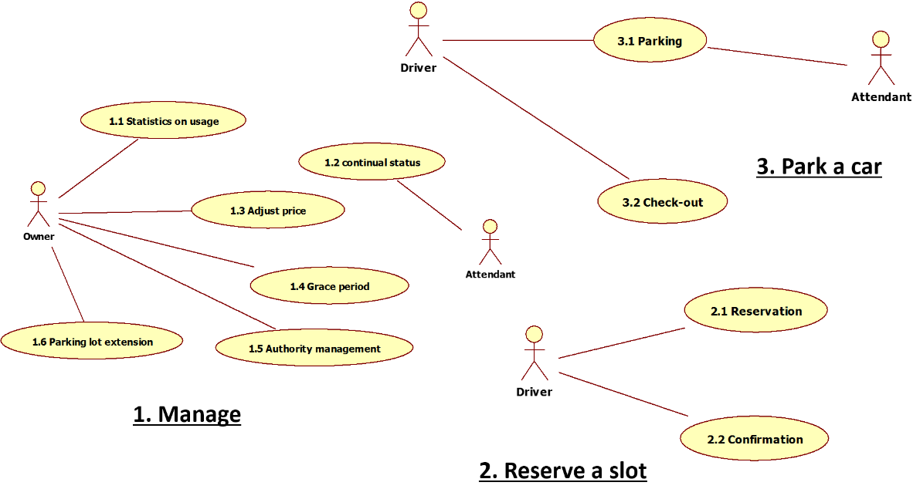

Figure 1. Use Case Diagram of Overall System

Constraints

Business Constraints
Following table describes constraints of business perspective.
ID | Description
CST-01 | The system should more efficiently utilize personnel and reduce the number of  people required to operate any given garage reducing operating costs.
CST-02 | The system should reduce traffic congestion and the chance for accidents inside the parking facilities reducing liabilities.
CST-03 | The system should be scalable to N facilities.
CST-04 | The system should reduce driver frustration and enable them to easily find a parking  facility with available parking slots and reserve them.
CST-05 | The system should more efficiently utilize the space in their parking facilities thereby  increasing profits.
Table 6. Business Constraints

Technological Constraints
Following table describes constraints of technological perspective.
ID | Description
CST-08 | The system cannot change the type of controller, sensors, or actuators (e g. gate lift servo), although use multiple controllers to accommodate a larger facility.
CST-10 | The system must check with the owner (course instructor) before you use open software.
CST-12 | The system should use JAVA as programming language.
CST-13 | The system should use Arduino MEGA 2560 (Wi-Fi enabled).
Table 7. Technological Constraints

Quality Attributes
We have defined 17 quality attributes, and these are described in document [5Team_Analysis_001].

Most Significant Quality Attributes
In this document we describe top 4 high priority quality attributes which can have a decisive impact on system quality and architecture.

QA ID | Quality Attributes | Priority | Difficulty
QA-08 | (Scalability) If owner add a parking lot, it should be reflected without stopping System. | H | M
QA-14 | (Availability) System shall be available for 24 * 7 * 365 without stop. | H | H
QA-17 | (Performance) System shall make a response for every request in 3 seconds. | H | H
QA-16 | (Safety) System shall not make any harm to people involved in this system. | H | M
QA-15 | (Security) System shall store private data with encryption | M | M

Table 8. Top priority quality attributes

System Context
This System context diagram describes interaction between key stakeholders and Sure-Park Management System.

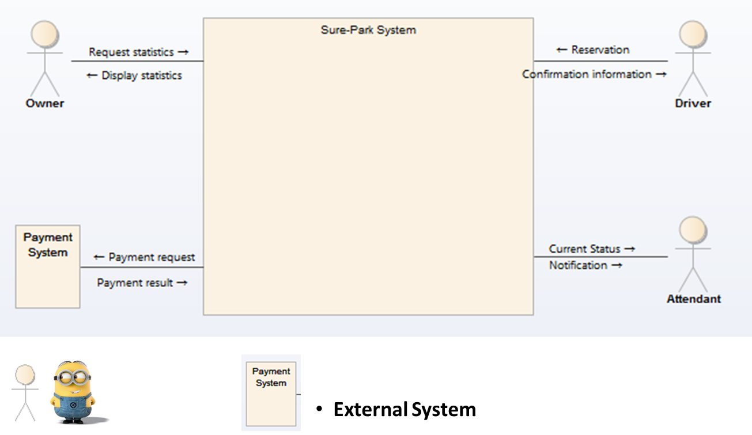
Figure 2. System Context Diagram

There are 3 key stakeholders, 1 external system and Sure-Park Management System.

The main activity with key stakeholders are defined as following:
- Drivers use to reserve a parking slot.
- Owner use to manage parking lot system and monitoring the system status.
- Attendant use to manage assigned parking lot.

The main activity with Payment system is defined as following:
- Payment system verify driver’s payment information.
- Payment system accept payment request.

System Scope
The scope of Sure-Park Management System development is defined as below.

Element | Description
Sure-Park Parking Lot | Control devices and monitor sensors in parking lot.
Sure-Park ParkHere | Provide user interface.
Sure-Park ParkView | Interact with driver at entry gate.
Sure-Park ParkServer | Manage parking lots and analyze the statistics information

Table 9. Development Scope

Overall System Architecture Design
This chapter describes overall system architecture and important architecture design decision.

Design decisions in early development stage
When we analyze customer requirements, we found there were several requirements and constraints for design decisions.
ID | Details | Consequences
CST-13 | The system should use Arduino MEGA 2560 (Wi-Fi enabled). | - We have to design “Parking Lot Controller” as an independent element.
FR-201 | System shall provide at least one method for parking lot reservation. | - We have to design “Reservation Client” as an independent element.  - We have to design network-based system to reserve a parking slot in distance.
FR-304 | System should be able to receive the confirmation information from driver. | - We have to design “Parking Lot Kiosk” as an independent element.

Table 10. Main requirements/constraints

In this point of view, we should make at least 3 independent elements. These decision affect a lot on our design for Sure-Park Management System.

Architecture Style
This section describes architecture style of overall system and quality attributes which should be considered according to each style.

System context : There are shared resources and services that large numbers of distributed clients wish to access, and for which we wish to control access or quality of service.
What should we do : By managing a set of shared resources and services, we can promote modifiability and reuse, by factoring out common services and having to modify these in a single location, or a small number of locations. We want to improve scalability and availability by centralizing the control of these resources and services.

In this situation, we decide to apply “Client-Server Architecture Pattern” for this system.

Client-Server Architecture Pattern
System has central server for managing parking related information and also has various clients for sharing data and status information with server. We applied Client-Server pattern because Server should gather and manage data and status information of each client and share that information with clients together.

Promoted Quality Attributes
Scalability : System can add more parking lots easily and manage various kinds of request/data systematically.
Modifiability : When requirements are changed, the most change will be made in server which has business logic for parking lot management system.
Security : Server can be a single point to access secure data.

Inhibited Quality Attributes
Reliability : Whole system should be stopped when server does not work properly.

Dynamic Perspective
This section shows dynamic view of overall system. Sure-Park management system consists of 5 independent sub-system. Following figure show dynamic structure of each sub-system and the relationships among them. Each sub-system operates with independent process.

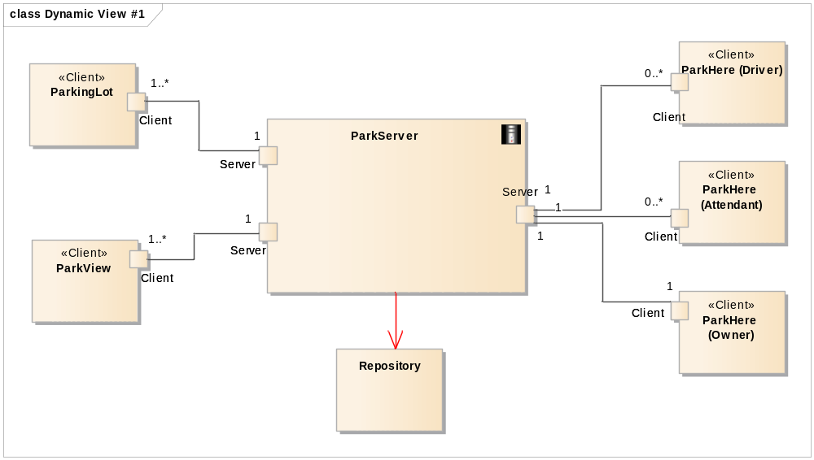
Figure 3. Dynamic perspective of overall system

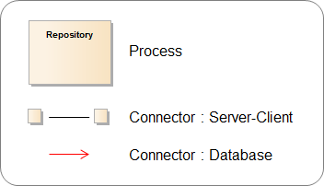

Figure 4. Legend for dynamic perspective

Every sub-system is connected with “ParkServer Process” as the center which has server role. ParkServer Process manages data from each Client Process and delivers necessary control information to ParkingLot Client.

Connectors
There are 2 types of connector. The first one is a connector between server and client using TCP/IP. The IP of server is static, 192.168.1.192, and this information is deployed in each clients. We want to design with DNS, but we cannot apply within restricted situation. The second one is a connector between server and database. We only provide one access point to database, to keep it secure, and we use JDBC driver to connect our mysql database.

Dynamic Behavior
This section describes system’s dynamic behavior for satisfying high level functional requirement.

(UC 1.1) Parking lot statistics
The operations of each element when owner request to display the statistics for parking lot.
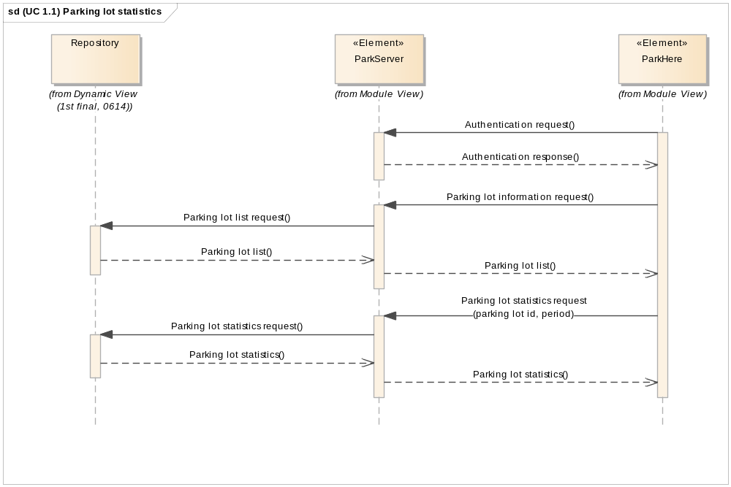
Figure 5. (UC 1.1) Parking lot statistics sequence diagram

(UC 1.2) Parking lot status
The operations of each element when attendant request to display current status of parking lot.
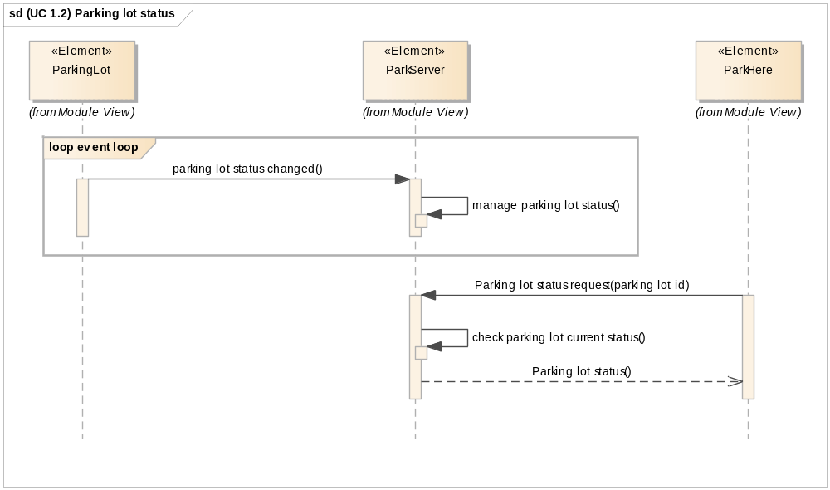
Figure 6. (UC 1.2) Parking lot status sequence diagram

(UC 1.3) Adjust parking fee
The operations of each element when owner request to adjust parking fee for selected parking lot.
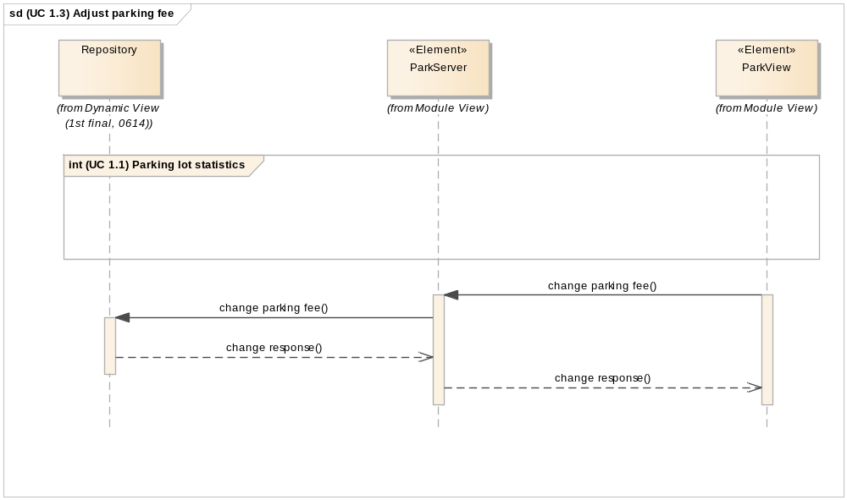
Figure 7. (UC 1.3) Adjust parking fee sequence diagram

(UC 1.4) Adjust grace period
The operations of each element when owner request to adjust grace period for selected parking lot.
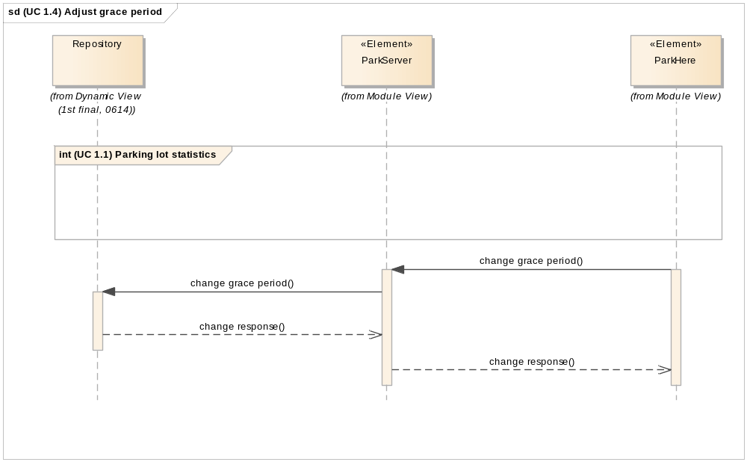
Figure 8. (UC 1.4) Adjust grace period sequence diagram

(UC 1.5) Authority management
The operations of each element when owner request to adjust grace period for selected parking lot.
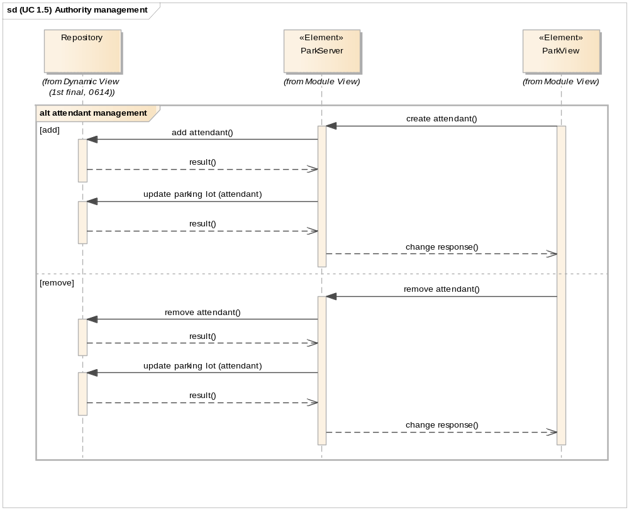
Figure 9. (UC 1.5) Authority management sequence diagram

(UC 1.6) Parking lot extension
The operations of each element when owner request to add/remove parking lots.
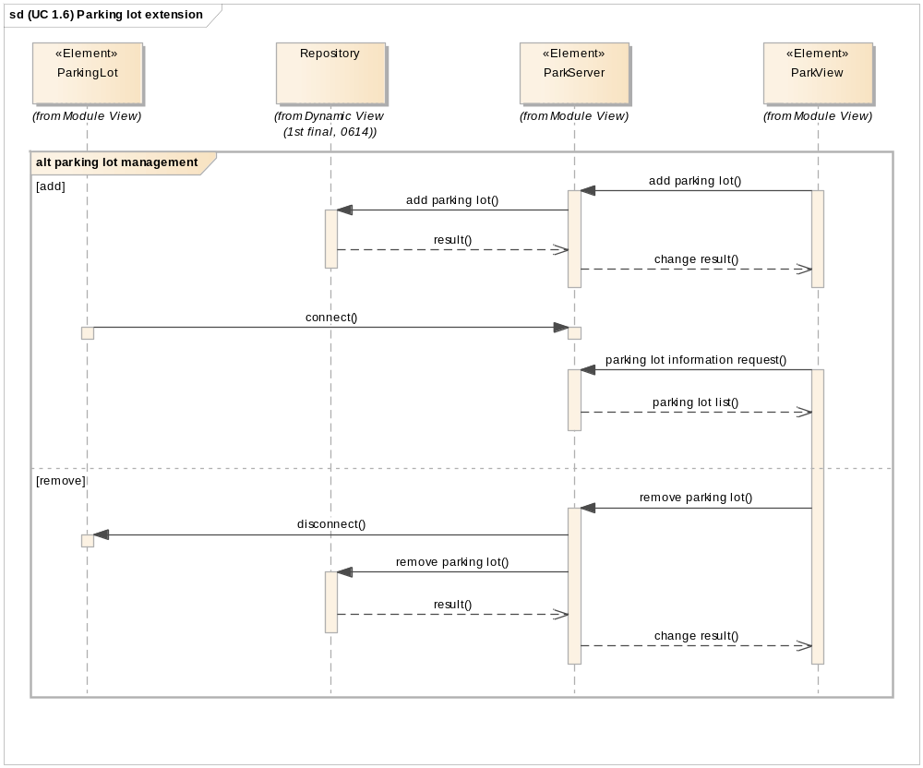
Figure 10. (UC 1.6) Parking lot extension sequence diagram

(UC 2) Reserve a slot
The operations of each element when driver make a reservation and confirm a reservation.
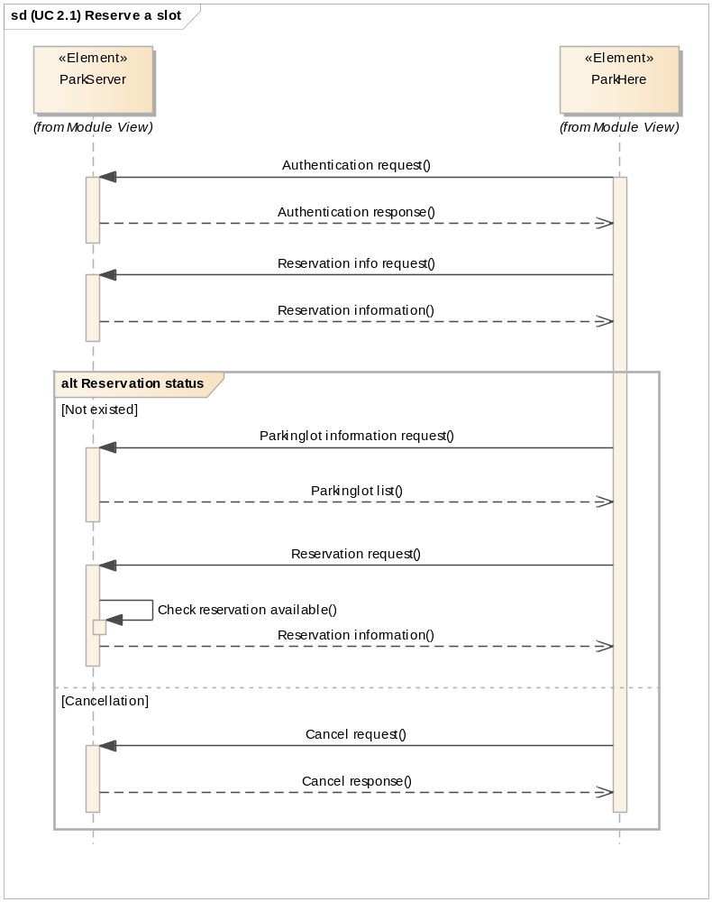
Figure 11. (UC 2) Reserve a slot sequence diagram

(UC 3.1) Parking
The operations of each element when driver arrives parking lot.
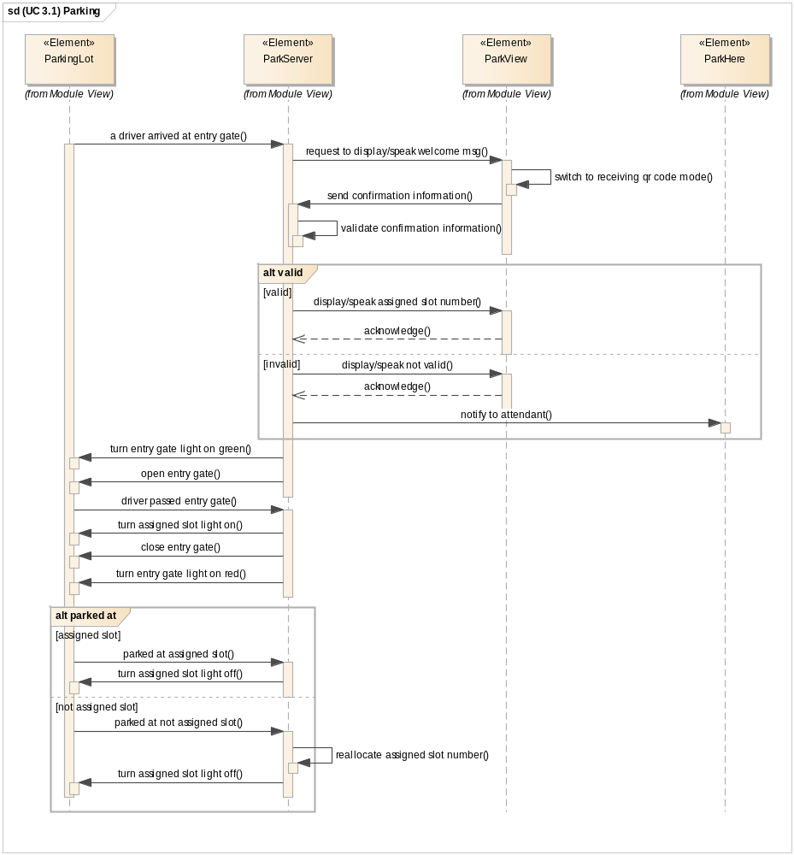
Figure 12. (UC 3.1) Parking sequence diagram

(UC 3.2) Check-out
The operations of each element when driver depart parking lot.
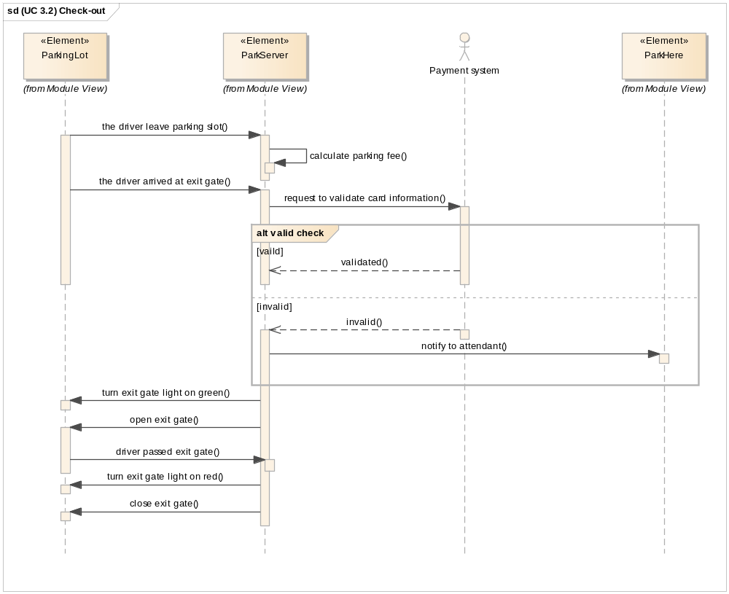
Figure 13. (UC 3.2) Check-out sequence diagram

Design Rationale Of Dynamic Perspective

Rationale for adopting ‘Client-Server’ Architecture pattern

We need a repository for storing and analysis of parking lot usage data, and the clients need to use authentication data (e.g. credit card, password and so on).
Alternative design…
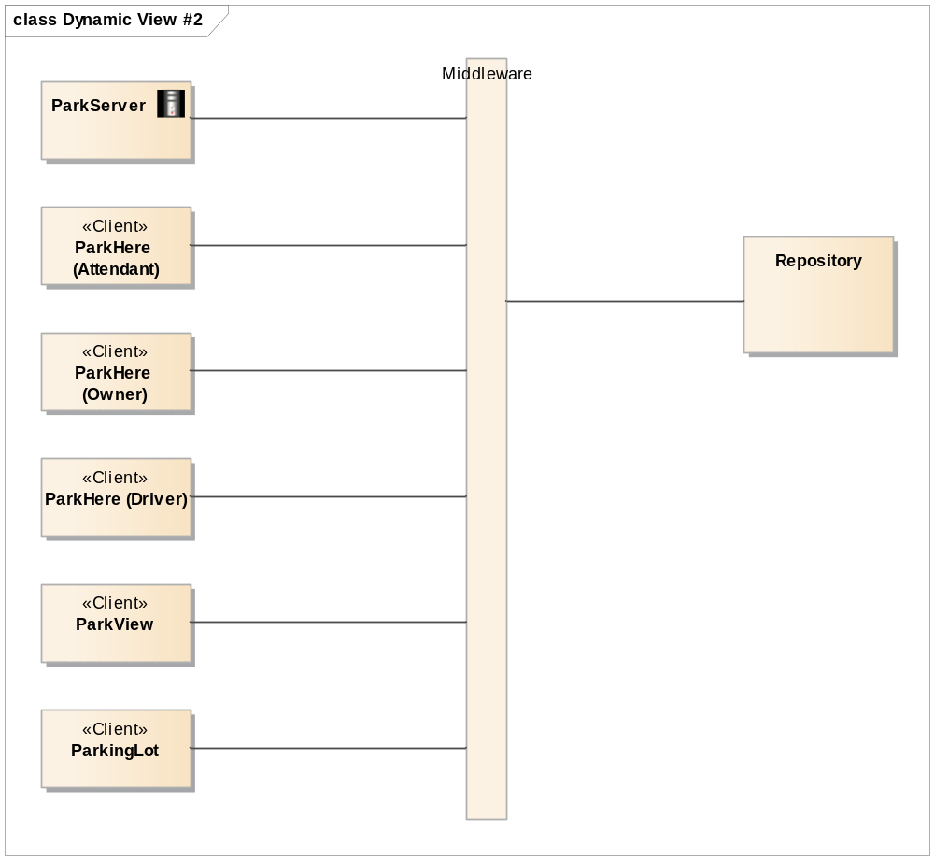
Figure 14 Dynamic design alternatives : Shared data with middleware

Reason for using database
ParkServer receives various kinds of data continuously, server have to provide reliable statistics information to owner, which will be used to manage the business. And server also should store user information with reliability and security.
In this situation, we decided to use database because we need to keep managing various kinds of data and to get consistency for data even though we can manage the data using data structure.

There are various kinds of database in this world. We decided to use MySQL in this project. After analyzing system requirement, we have found that MySQL can provide scalability, availability, and portability. We have not chosen NoSQL database because we do not have experience to use NoSQL before, and we do not have much time to debug when we meet critical problem with it.

Design Decision | Manage data using MySQL
Reason | - Need to keep maintaining various kinds of data during operation
Promoted  Quality Attributes | Availability, Reliability, Security, Performance
Trade-Off | Database can be a performance bottleneck
Table 11. Rationale of using Database

Analysis for selecting protocol
There is a JSON based protocol between elements (except database). We analyzed several candidate protocols, and the result is as in the below table.

Protocol | Strength | Weakness
HTTP | Extensibility for using Web | Need web server
HTTPS | Packet security through encryption | Performance decrease using encryption technology.  ‘Key’ management for encryption
JSON | Compatibility for different languages  Support various libraries  Good performance | Need JSON parsing library
XML | Standardized format  Widely used standard | Parser is complex and heavy  Poor performance when format is complex
RAW Object Socket  (java) | Can use in Java easily | Restriction to use in different languages
String Base Socket | Easy to parse based on string  Can be used in low performance devices | Easy to restore data after cracking network packet (security weakness)
Binary Base Socket | Large data can be transferred with small bandwidth | High possibility to miss parsing bit-unit command
Table 12. Result of protocol analysis

JSON based socket is selected according to above analysis, because of compatibility for different languages, good performance, and security. JSON based protocol, which has great extensibility for mobile devices, has been selected for user interface.

Design Decision | JSON based protocol is selected for user interface
Reason | Extensibility to various kinds of clients like mobile device
Promoted  Quality Attributes | Modifiability, Security
Trade-Off | Message can be longer than string base socket, it can make performance issue.
Table 13. Rationale of using JSON

Physical Perspective
Figure 8. shows physical connection among physical elements. Every element is connected to server through WIFI and dedicated port.

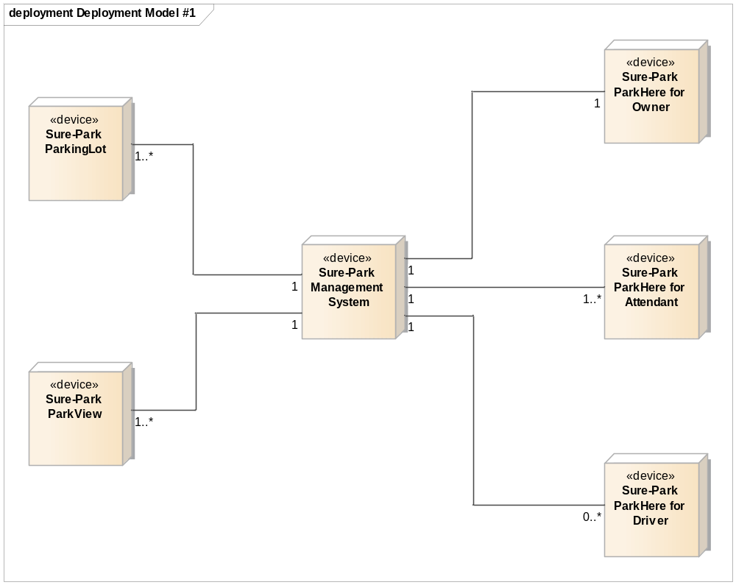
Figure 15 Physical Perspective of Overall System Architecture

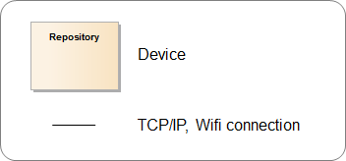

Figure 16. Legend for physical perspective

Physical Perspective shows about the hardware information, network information. Most design rationales of this design comes from early design decisions, in Table 10.

Design Rationale Of Physical Perspective

Design alternatives : Arduino with server
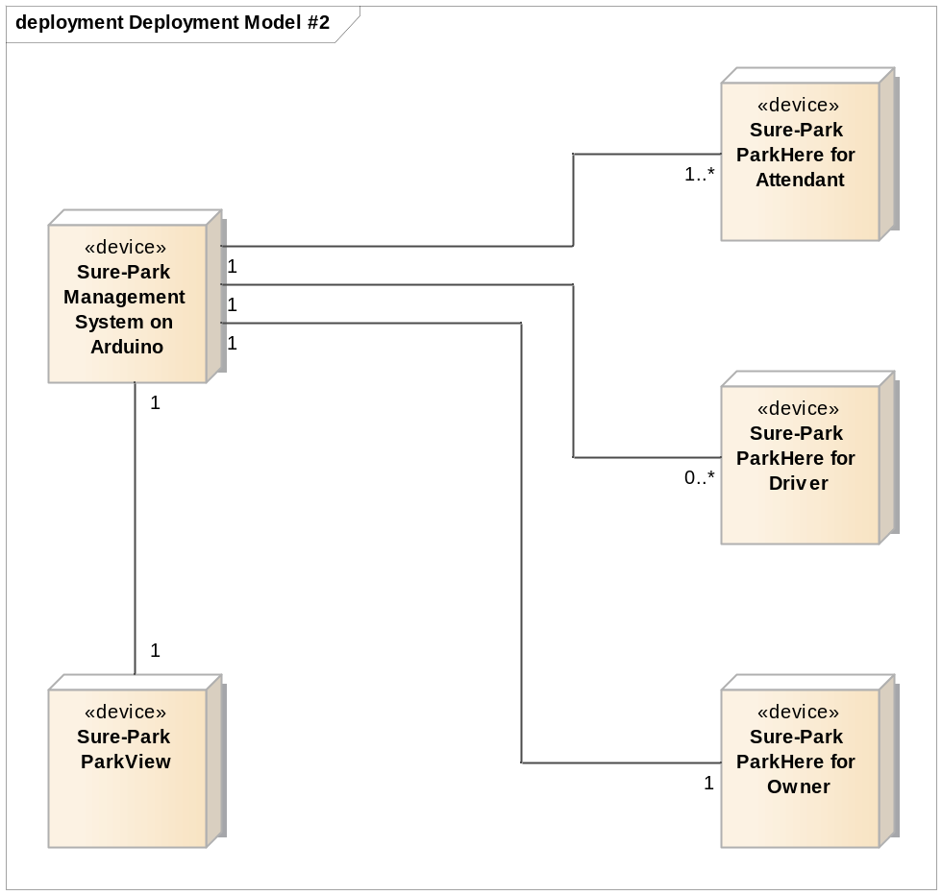
Figure 17 Physical design alternatives : Arduino with server

There are a lot of solutions to implement server using Arduino. So, we made an alternative physical design to reduce network complexity, achieve easiness on development and test.

Detailed comparison using Quality attributes
To verify this design, we made a test on Arduino focusing on performance of device. The criteria for verification is as follows, mainly performance.

- Can manage several socket connections? Conditional possible.
- Can monitor sensors in Arduino with network loads? Conditional possible → accuracy goes down.
- Can store data with network overloads and control devices? Impossible.
- Can manage data using database? Impossible.

We tested with these criteria, and found out that performance of Arduino was not able to process this design. So we designed an additional device for server, as Figure 8.

Static Perspective
Sure-Park Management System consists of 4 sub-systems and the static view of use relationship is as in the following figure.

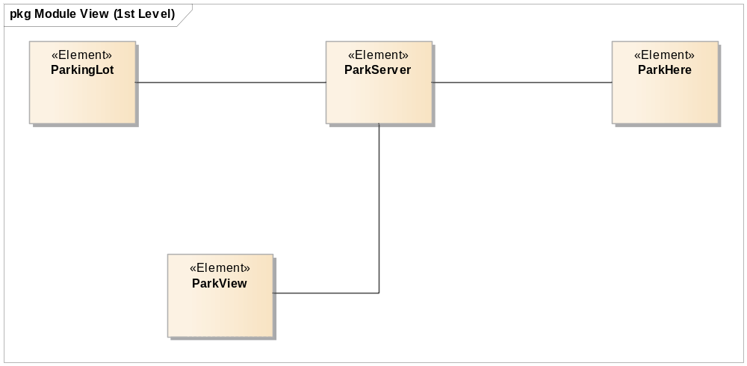
Figure 18 Static Perspective of Overall System Architecture

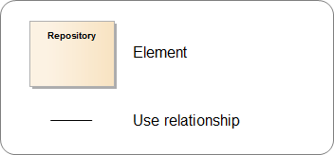
Figure 19. Legend for physical perspective

This is typical ‘Client-Server’ architecture pattern which server is in center of architecture. We assigned developer using subsystems of static perspective.

Elements description
In 1st level of system module view, we have 4 elements – ParkServer, ParkingLot, ParkHere and ParkView. Detailed information of each element is as follows.

Elements | Responsibility | Constraints | # of reqs. | Assignee
ParkServer  (SE-01) | * manage reservation, parking, statistic data  * manage authority : owner, driver, attendant | * must communicate with lots of other elements (parking lot, applications)  * must stay connected with parking lot | 62  (97%) | Yongchul Park,  Jaedo Jin
ParkingLot  (SE-02) | * control devices in parking lot by management system's request  * monitor sensors in parking lot and send to management system | * can add/remove devices/sensors in parking lot  * just follow command of management system | 16  (25%) | Daedon Jeon
ParkHere Owner  (SE-03) | * display statistics for parking lot  * manage authorities for registered attendants  * manage parking lot price, grace period  * add/remove parking lots | * controlled by various authorities  * display statistics for owner in 3 seconds | 17  (27%) | Kimoon Lee
ParkHere  Attendant  (SE-04) | * display current status of parking lot  * receive notification for emergency |  | 3  (5%) | Kimoon Lee
ParkHere  Driver  (SE-05) | * reserve a parking slot with reservation information  * display reservation information with confirmation information  * can cancel the reservation |  | 12  (19%) | Kimoon Lee
ParkView  (SE-06) | * interact with driver at entry gate  * display/speak welcome message  * receive confirmation information from driver via QR code  * display/speak assigned parking slot information | * need to reduce energy consumption  * controlled by management system | 3  (5%) | Yongchul Park
Table 14. Element description / work assignment

Traceability between requirements and elements
We made a traceability matrix between requirements and elements. It shows that we assign whole requirements to module elements.

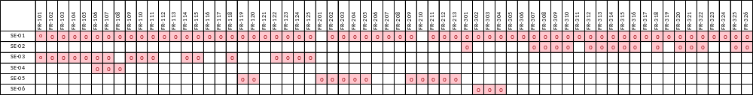

Tactics

Tactics For Availability
All the operation cannot work if connection to server is failed when we use Client-Server pattern. It is the most important to keep maintaining connection with server for securing system availability. We used ping-echo method to check if connection to server is stable.

Using Ping-Echo Mechanism
…

Related Quality Attributes

Using ping-echo strategy, …

QA-ID | Description | Using Tactics | Result
Table 15. Quality Attributes and Tactics

Tactics For …

Subsystem Architecture Design
This section describes each subsystem’s architecture design.

1.2.2 Organizational Context 7
1.2.3 Business Context 8
1.2.4 Technological Context 8
2.1.1 System Level Functional Requirement 9

2 Architectural Drivers 9
2.1 High Level Functional Requirements 9
2.2.1 Business Constraints 10
2.2 Constraints 10
2.2.2 Technological Constraints 10
2.3.1 Most Significant Architectural Drivers 11
2.3 Quality Attributes 11
4.2.1 Responsibility Of Runtime Elements 14

3 System Context 12
3.1 System Scope 12

4 Overall System Architecture Design 13
4.1 Architecture Style 13
4.2 Dynamic Perspective 13
4.2.2 Connectors 15
4.2.3 Dynamic Behavior 15
4.2.4 Design Rationale Of Dynamic Perspective 20
4.3.1 Design Rationale Of Physical Perspective 25
4.3 Physical Perspective 24
4.5.1 Tactics For Availability 28
4.4 Static Perspective 26
4.5 Tactics 28
4.5.2 Tactics For Modifiability 30
5.1.1 Dynamic Perspective 32

5 Subsystem Architecture Design 32
5.1 Warehouse Management Server Architecture 32
5.1.2 Design Rationale Of Server Architecture 33
5.2.1 Static Perspective 34
5.2 Customer UI Application Architecture 34
5.3.1 Static Perspective 35
5.3 Supervisor UI Application Architecture 35
5.4.1 Static Perspective 35
5.4 Robot Controller Architecture 35
5.4.2 Dynamic Perspective 36
5.4.3 Design Rationale Of Robot Controller Architecture 36
5.5.1 Static Perspective 37
5.5 Warehouse Controller Architecture 37
5.5.2 Dynamic Perspective 37

